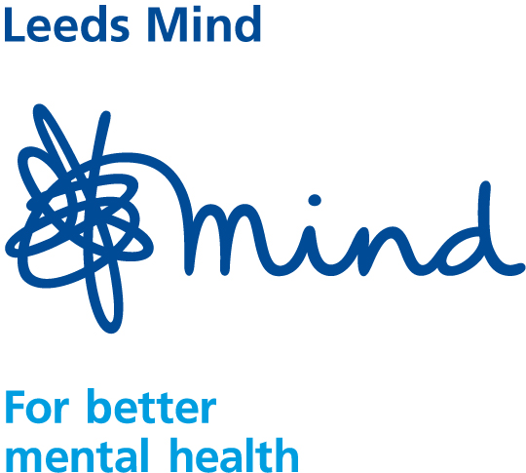
Leeds Mind ‘Wellbeing’ Befriending Service

What is the Befriending Service?

The ‘Wellbeing’ befriending service is an integral part of Leeds Mind. It is a service, which apart from the coordinator, is delivered exclusively by volunteers.

Who is the Service for?
It is a service for people experiencing mental health distress and one of the main purposes of Befriending is to address the isolation, loss of confidence and lack of motivation that can develop with mental health problems. Befriending may help people who are on the road to recovery and need short term support, or be aimed at individuals whose long-term mental health difficulties mean they are more likely to experience a limited social life. It is important to note that all befriending partnerships are time-limited.

Befriending provides opportunities for:

Being valued and respected

Experiencing a period of stability with a reliable trustworthy person

Being involved in a managed relationship

A period of respite for the recipient or their carer

Providing hope that life can be better

What does a Befriending Volunteer do?
A befriender is a volunteer who has offered to undertake regular visits or ‘outings’ with a service user. Both parties will meet up on a regular basis and share a social activity together. What that activity is, is entirely up to the befriender and the service user so long as it is ethical, practically viable and affordable. Typical activities undertaken by mutual interest are: walking; cycling; swimming; bowling; gardening; trip to town; cinema or going for a coffee or maybe help attending appointments. Domestic support is not offered as part of the Service. Example: Weekly food shopping, cleaning or DIY. The service is aimed at both parties experiencing an enjoyable social activity.

Leeds Mind ‘Wellbeing’ Befriending Service

What is befriending?
Befriending is a service offering a supervised, time limited, one to one social relationship. Befriending activities may include:-
• Going to the Cinema
• Walking (the dog)
• Home visits for tea and chat
• Going for a coffee
• A trip into town
• An activity at a sports centre.
• Eating out
• Anything you fancy that is ethical and affordable.

How much time is involved?
The length and frequency of a befriending visit is up to the persons concerned. It could be:-
• 1 to 2 hours or more @ weekly or 2 weekly intervals.
• During the day evening midweek or weekend.
• For a period of 4 to 12 months
• Tailored to your needs within reason

What safeguards are there?
We follow best practice. Volunteers are interviewed, with references and CRB checks obtained; they receive training and regular supervision. Service users undergo risk assessment and no person with a history of violence or aggression is accepted into the scheme.

Are there any costs involved?
Volunteers can claim back money spent on things like bus fare, cinema tickets, coffees etc. Service users pay for themselves. The cost of an activity must be affordable for the service user.

Who can receive befriending?
People can receive this service if they are socially isolated, stuck in a rut, or experience only unsupportive relationships that are in some way ‘unhealthy’.

How can Befriending help?
It can:-
• provide valuable respite for the recipient or their carer.
• help break unhealthy patterns and habits
• provide a period of stability with a reliable trustworthy companion.
• provide hope that life can be more enjoyable with the right input.
• provide someone to reflect with on what it means to be valued and treated with respect.
• help in many ways and is different for everyone.

How are partnerships formed?
An interest and activities questionnaire forms the basis of partnership matching together with the coordinators assessment. After being introduced, partners are asked to meet 2 or 3 times during which they can consider the terms of the partnership.

For more information please contact

Leeds Mind ‘Wellbeing’ Befriending Service Co-ordinator
Clarence House
11 Clarence Road
Horsforth
Leeds
LS18 4LB

Tel: 0113 3055809
Email: val.ward@leedsmind.org.uk

Access
- Basement and ground floor wheelchair accessible by ramps.
- Wheelchair accessible toilet on the ground floor.

